**­SIX MONTH INDUSTRIAL TRAINING**

**ON**

**FULL STACK IN JAVA**

**AT**

**Excellence Technology**

*Submitted in partial fulfilment for the award of the degree of*

# **MASTER OF COMPUTER APPLICATIONS**

in

**Computer Applications**

**January 2024 to June 2024**

***Under the guidance of***

# **Guide name:-Neetu Mam**

# **Designation: Trainner**

# **Excellence Technology**

## **Submitted By:**

## **Mohit Singh (22PCA007)**

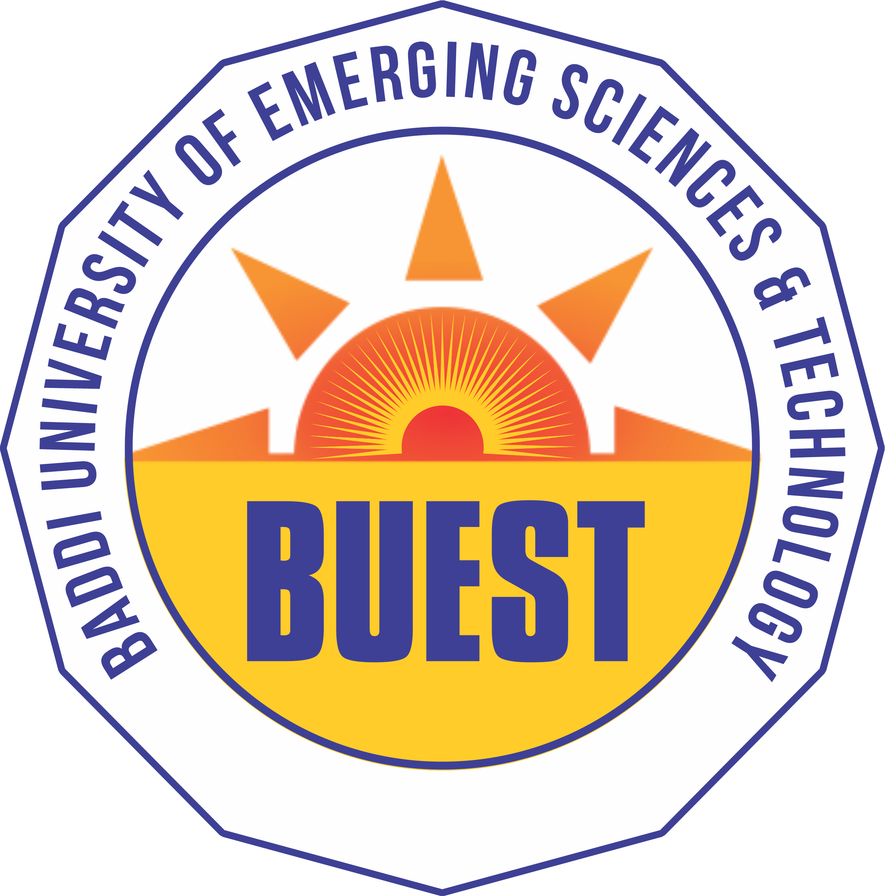

DEPARTMENT OF COMPUTER APPLICATIONS

SCHOOL OF ENGINEERING AND EMERGING TECHNOLOGY (SEET)

BADDI UNIVERSITY OF EMERGING SCIENCES AND TECHNOLOGY, BADDI (H.P) (2024)